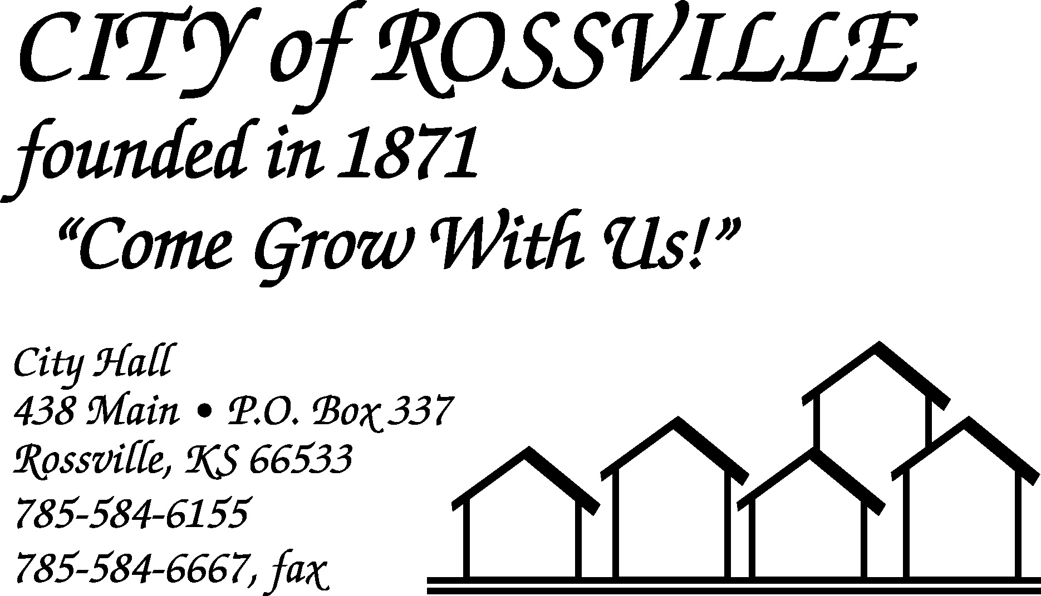

City Hall July 19, 2021

The Rossville City Council meeting was called to order on Monday, July 19, 2021 at 7:00 pm by Mayor Kenneth Wichman.

Council members present were Christi McKenzie, James Meyer, Toby McCullough and Trish Heim. Dan Glotzbach was absent.

Also, present were Jason Connell, Brad Kirk, Andrea Martin, Daniel Dugan and Harry Hammer III.

Motion by James Meyer to approve minutes of the July 6, 2021 meeting as written was seconded by Trish Heim and carried.

The following bills were presented;
Alan Zlatnik $1,505.33 EFTPS-Fed Wh $1,057.85
Tracey Taylor 826.41 EFTPS-FICA 2,152.96
EMPower Retirement 380.00 Lisa Stum 1,134.32
Michael Kirk 1,189.92 Grace Hier 60.00
Kansas Payment Center 123.69 Randall Anderson 931.49
Kansas Withholding Tax 497.94 Bowe Behymer 465.14
Douglas Schreiner 379.13 KP & F 1,050.40
Trent Stanley 1,096.22 KPERS 1,285.97
Jacob Akin 170.34 Jason Connell 1,040.42
Kerry Dick 427.18 Harry Hammer III 174.26
Tina Dick 455.44 Blue Cross Blue Shield of Ks. 9,908.67
Casey’s 1,187.97 CenturyLink Business Serv. 521.16
Hamm Inc. 910.67 Kansas One-Call System, Inc. 40.80
A T & T First Net 474.71 Rossville Water Service 75.00
Sam’s Club 651.92 AFLAC 520.88
Amazon.com 26.98 Schulte Supply Inc. 2,071.52
Select Imaging 704.00 Century Business Technologies 155.43
Evergy 941.65 State Industrial Products 358.50
Stephen M. Connelly, CPA, PC 1,850.00 US Bank 163.26
Stum’s Concrete 700.00 U.S. Post Office 110.00
Universal Chemical LLC 430.45 Evergy 2,233.53
TOTAL 40,441.51

Motion by Toby McCullough to pay bills as presented totaling $40,441.51 was seconded by Christi McKenzie and carried.

Motion by James Meyer to approve agenda with the addition of Andrea Martin and Daniel Dugan was seconded by Christi McKenzie and carried.

Andrea Martin and Daniel Dugan were present to discuss recent warning that was received from the police department regarding code violations. Martin reported that several dumpsters of stuff had been removed and inquired about what other items were considered code violations. Following discussion council instructed Martin to continue communications with the police department on progress and plans for remediation of violations. Chief Connell reported that he would meet with Martin and review issues.

Clerk presented and reviewed end of second quarter finance report.

Utility Employee Brad Kirk presented bid for painting of water tower from Insco Industries in the amount of $166,845.00. This being the lowest bid received motion by Christi McKenzie to accept bid was seconded by James Meyer and carried.

Utility Employee Brad Kirk reported that all the concrete ditches except the one behind the nursing home have been clean out. Council discussed letters to be mailed to residents regarding maintenance of easement property.

Utility Employee Brad Kirk reported that the Rossville Township had contracted with Shawnee County to have 54th Street from the City limits to the cemetery chip and sealed and inquired about having Shawnee County continued chip and seal to Main Street. Cost to the City would be $3,000.00 to $4,000.00. Motion by Christi McKenzie to have Shawnee County chip and seal road from City limits to Main St. was seconded by Trish Heim and carried.

Police Chief Jason Connell reported that several tickets had been issued for code violation and that his department would continue with code enforcement.

Mayor reported that City Attorney Stanley Oyler had inquired about proceeding with lease agreement for land to allow walking trails. Following discussion council requested that Myron Lienwetter be asked to attend next meeting to answer some questions regarding plans.

Toby McCullough reported that the Rossville Community Foundation had agreed to pay for half the cost to construct new City of Rossville sign at the south entrance to the city with the City paying the other half. Cost for one sign would be $1,625.00. Motion by Toby McCullough to proceed with construction of south sign and pay half the cost was seconded by James Meyer and carried. Council instructed utility department to remove existing signs at the south and north entrances.

Council reviewed proposed 2022 budget. Following review council determined that the proposed mil levy for 2022 would be set at 47.992 mils with hearing scheduled for September 7, 2021 at 7:00pm.

Clerk presented application from the American Legion Post #31 for special event beer garden permit in the 400 block of Main and the Rossville City Park. Motion by James Meyer to approve permits was seconded by Toby McCullough and carried.

Clerk requested permission to allow Tracey Taylor to attend virtual Neptune Connect Users Conference August 23-25, 2021 at cost of $50.00. Motion by Toby McCullough to allow was seconded by Trish Heim and carried.

Resolution Adopting the Kansas Homeland Security Region J Hazard Mitigation Plan was presented. Motion by Trish Heim to adopt resolution was seconded by Toby McCullough and carried.

Request for water bill adjustment due to leak at 436 Pearl Street was presented. Motion by James Meyer to adjust by half the overage was seconded by Toby McCullough and carried.

Motion by Trish Heim to adjourn was seconded by Toby McCullough and carried. Meeting adjourned at 8:25 pm.

City Clerk
Lisa M. Stum

